**Spartans Sports Booster**

Support our athletes and coaches so we can help with needed equipment, supplies, and expenses.

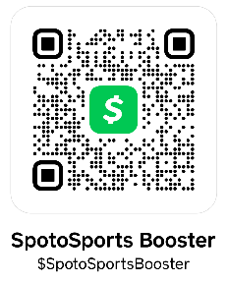

When you join our booster club, you also will receive a code which will allow you to purchase a Hillsborough County Sports Parent Pass for $73 (student season passes - $73 for all activities, $43 for 10 games - can be purchased on the district website without a code). This pass allows you into every regular season Hillsborough County athletic event for one price! No need to purchase tickets for every game, just save the image to your phone! Parent passes also can be used for ALL Hillsborough County regular season sports – including middle school athletics – and includes HOME parking for football games. **Each Booster Club membership is $25.** Please complete this form and return check or cash to Spoto High School, attention Booster Club. Or send payment to our Cash App account $SpotoSportsBooster and email this form to [spotoboosterclub@yahoo.com](mailto:spotoboosterclub@yahoo.com).

Student(s) Name and Sport (s): ________________________________________________________________

Parent Name 1: _____________________________________________________________________________

Email address: _____________________________________________________________________________

Phone: ___________________________________________________________________________________

Parent Name 2: _____________________________________________________________________________

Email address: _____________________________________________________________________________

Phone: ___________________________________________________________________________________

**Total number of memberships ordered:** _______________

**Total amount included:** _________________

After completion of this form, you will get an email with a code from our booster club for you to purchase the parent passes.

Twitter Instagram Email

@SpotoBoosterCl1 @spotoboosterclub spotoboosterclub@yahoo.com